-- 1. Create a prepared statement to display all employees' names in the department ? (Dno) .

**PREPARE** stmt **FROM** 'SELECT * FROM EMPLOYEE WHERE Dno = ?';

**SET** @aid = '5'

**EXECUTE** stmt **USING** @aid;

**DEALLOCATE** **PREPARE** stmt;

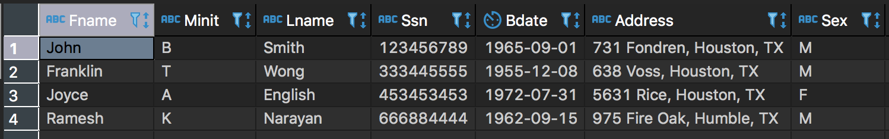

-- 2. Define a procedure to display all Clients (Cname) who have some project with Department 5.

**DELIMITER //**

**CREATE** **PROCEDURE** GetAllClients()

**BEGIN**

**SELECT** Cname

**FROM** CLIENT

**WHERE** Pno

**IN**(**SELECT** Pnumber

**FROM** PROJECT

**WHERE** Dnum = 5);

**END**; //

**DELIMITER ;**

**CALL** GetAllClients();

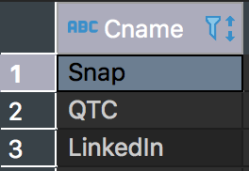

-- 3. Create a procedure to display the number of employees in the department, using Dno as the IN variable.

**DELIMITER //**

**CREATE** **PROCEDURE** GetAllClientsIn(**IN** Dno **INT**)

**BEGIN**

**SELECT** Cname

**FROM** CLIENT

**WHERE** Pno

**IN**(**SELECT** Pnumber

**FROM** PROJECT

**WHERE** Dnum = Dno);

**END**; //

**DELIMITER ;**

**CALL** GetAllClientsIn(5);

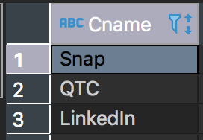

-- 4. Create a procedure to select the total number of projects of a department, using Dname as the IN variable, and define an OUT variable for the number of projects.

**DELIMITER //**

**CREATE** **PROCEDURE** TotalProjects(

**IN** name **varchar**(15),

**OUT** totalNumber **INT**)

**BEGIN**

**SELECT** **count**(Dnum)

**INTO** totalNumber

**FROM** project

**WHERE** Dnum **in** (**select** Dnumber **from** department **where** Dname = name);

**end**; //

**DELIMITER ;**

-- DROP PROCEDURE TotalProjects;

**CALL** TotalProjects('Research', @total);

**SELECT** @total;

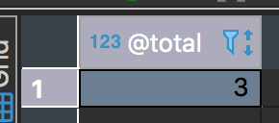

-- 5. Create a trigger on WORKS_ON, if a new tuple with Hours=NULL is inserted, set the Hours to 0.

**DELIMITER //**

**CREATE** **TRIGGER** exampleTrigger **BEFORE** **INSERT**

**ON** WORKS_ON

**FOR** **EACH** **ROW**

**BEGIN**

**IF** **NEW**.Hours **IS** **NULL** **THEN**

**SET** **NEW**.Hours = 0;

**END** **IF**;

**END**; //

**DELIMITER ;**

-- DROP TRIGGER 'exampleTrigger';

**INSERT** **INTO** WORKS_ON(Essn, Pno, Hours) **VALUES**(888665555, 10, **NULL**);

**SELECT** * **FROM** WORKS_ON;

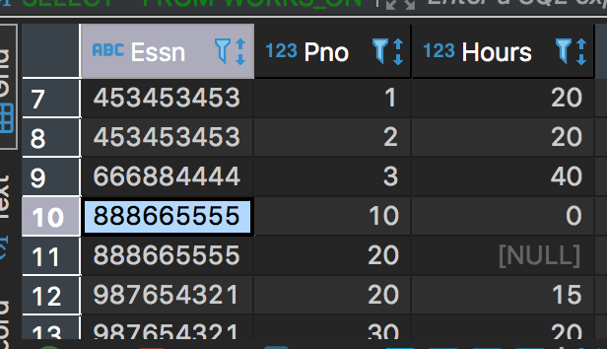

-- 6. Create a table with attributes SSN, dependent_name and ChangeTimeStamp, whenever a new tuple is inserted into DEPENDENT table, record the operation using a trigger.

**CREATE** **TABLE** newTable(

SSN **varchar**(9),

dependent_name **varchar**(25),

ChangeTimeStamp **DateTime** **DEFAULT** **CURRENT_TIMESTAMP**

);

**DELIMITER //**

**CREATE** **TRIGGER** dependent_audit **BEFORE** **INSERT** **ON** DEPENDENT

**FOR** **EACH** **ROW**

**BEGIN**

**INSERT** **INTO** newTable(SSN, dependent_name) **VALUES** (**NEW**.Essn, **NEW**.Dependent_name);

**END**; //

**DELIMITER ;**

-- DROP TRIGGER 'dependent_audit';

-- DROP TABLE newTable;

**INSERT** **INTO** DEPENDENT(Essn, Dependent_name, Sex, Bdate, Relationship) **VALUES**('123456789', 'Kyle', 'M', '1967-06-06', 'Husband');

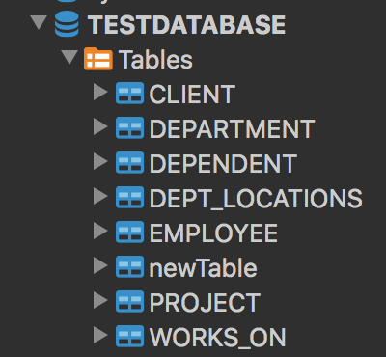

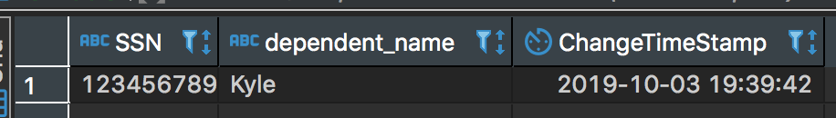

-- 7. Create a trigger on CLIENT, whenever a tuple is deleted, delete all the tuples in PROJECT table and WORKS_ON table with the same Pno as the deleted tuple from CLIENT.

**DELIMITER //**

**CREATE** **TRIGGER** client_trigger **AFTER** **DELETE** **ON** Client

**FOR** **EACH** **ROW**

**BEGIN**

**DELETE** **FROM** WORKS_ON **WHERE** Pno = **OLD**.Pno;

**DELETE** **FROM** PROJECT **WHERE** Pnumber = **OLD**.Pno;

**END**; //

**DELIMITER ;**

**DELETE** **FROM** CLIENT **WHERE** Cname ='Google' **AND** Pno = '20';



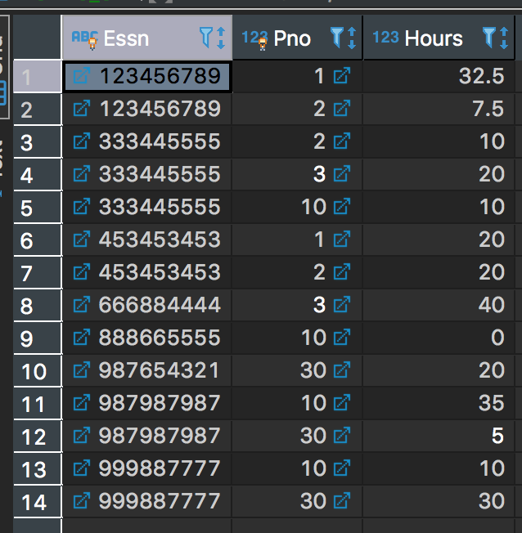

-- 8. Create a trigger on EMPLOYEE, whenever a new employee is inserted, if the employee has salary higher than his/her supervisor, set the employee's salary to NULL.

**DELIMITER //**

**CREATE** **TRIGGER** employee_trigger **BEFORE** **INSERT** **ON** EMPLOYEE

**FOR** **EACH** **ROW**

**BEGIN**

**IF** **NEW**.Salary > (**SELECT** Salary **FROM** EMPLOYEE **WHERE** Ssn = **NEW**.Super_ssn) **THEN**

**SET** **NEW**.Salary = **NULL**;

**END** **IF**;

**END**; //

**DELIMITER ;**

**INSERT** **INTO** EMPLOYEE(Fname, Minit, Lname, Ssn, Bdate, Address, Sex, Salary, Super_ssn, Dno) **VALUES**('Jason', 'M', 'Hannanto', '000111222', '1997-04-23', '1528 Ethel, Alhambra, CA', 'M', '60000', '888665555', '5');

